Track Builder Persona

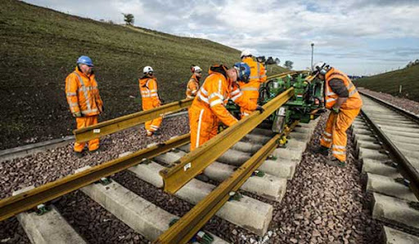

**Name:** Tom Miller

**Age: 29**

**Residence :** Pittsburgh PA

**Occupation:** Track Builder

**Biography(small description of user) :** Born and raised in a blue-collar neighborhood of Pittsburgh, Tom has always been fascinated by the vast network of railways that crisscross America. From a young age, he was drawn to the raw power and intricate engineering of trains. Tom is a rugged, hands-on worker with a deep respect for the history and importance of the railroad industry. He's known for his strong work ethic, practical skills, and a no-nonsense attitude. Tom's life has been shaped by the railroads, not just professionally but also personally, as it's where he’s met his closest friends and where he finds his greatest sense of purpose.

**Education Level:** High School Diploma/GED

**Salary Range:** $45,000 - $60,000

**Technology Comfort Level :** Moderate. Tom is comfortable with the technology required for his job, including machinery used in track laying and maintenance. However, he prefers physical labor and hands-on work over computer-based tasks.

**Hobbies :** Model railroading, hiking in the Pennsylvanian wilderness, and working on his vintage car collection. He also enjoys local history and often volunteers for community projects, especially those related to preserving Pittsburgh's industrial heritage.

**Goals :** Becoming a supervisor or manager in the railroad construction sector.

**Resources :**

Image: <http://www.railway-fasteners.com/news/how-to-build-a-railway-track.html>

Demographics: <https://www.zippia.com/builder-jobs/demographics/>